1. 1. 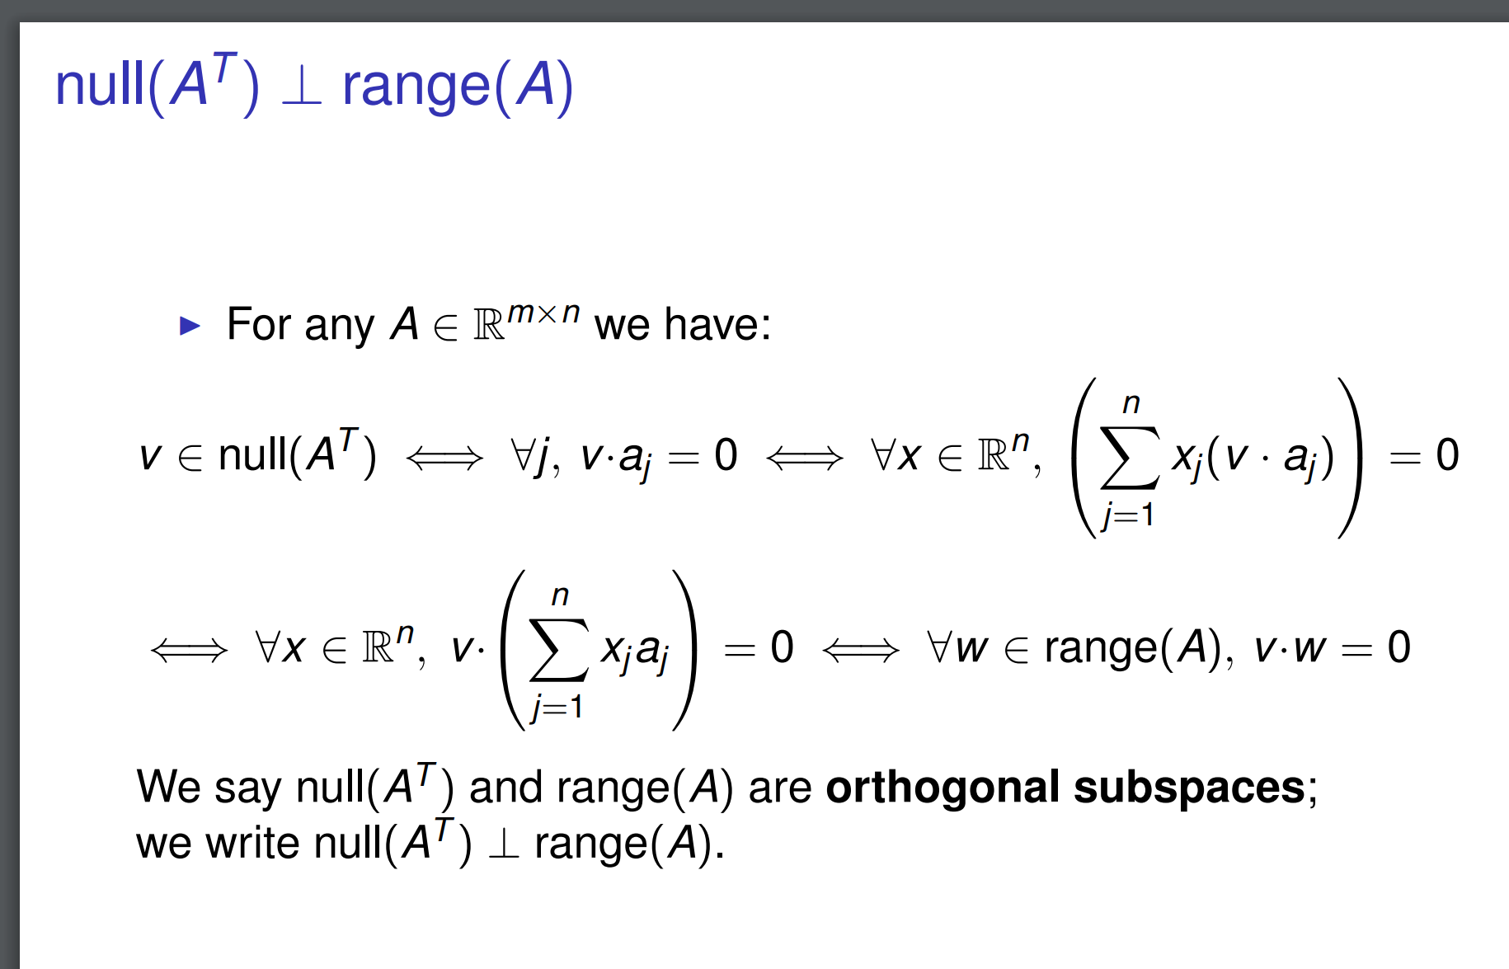  
      (Note: key to understanding the second summation is thinking how to represent matrix multiplication of Ax in terms of dot product… try it with a 2x2 matrix)

Note that the second part of the question as appeared in the exam.doc.ic.ac.uk is wrong, It should be showing that the intersection of range(A) and null(A^T) contains the 0 vector instead of showing that the intersection of range(A) and null(A) contains the 0 vector. Since the later is basically not true (consider the matrix A to be [[0,1],[0,0]], its null space is [1,0]^T and its range space is [1,0]^T as well).

* 1. 1. range(A) = [ [1, 2, -1]T [-1, -2, 11]T ]

null(A) = [ [2, -1, 0]T ]

* + 1. Apply Gram-Schmidt here? But the answers are not nice!!! :(

range of A is [[1,2,-1]^T/sqrt(6), [1,2,5]^T/sqrt(30)] and the null space is [[2,-1,0]^T / sqrt(5)]

* + 1. ⅕ [2, -1, 0]T + 19/25 [1, 2, -1]T + 4/25 [-1, -2, 11]T

b_r = [⅗, 6/5, 1/5]^T b_n = [⅖, -⅕, 0]

* 1. L = [1, 0, 0

2, 0, 0

-1, 0, sqrt(10)] Not positive (semi) definite

1. 1. 1. The 1-norm of a vector is the sum of the absolute values of all the elements in the vector.

The 1-norm of a matrix is the maximum absolute column sum.

* + 1. sup{the norm of (Ax) where x is vector and its norm is 1} TODO: prove l_1 norm is subordinate norm.
    2. k(A) = 7 * 2 = 14
  1. 1. 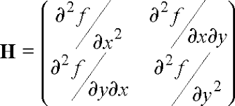
     2. **A:** H = [2, 0

0, 2] => det(H) = 4 (> 0)

At point (0,0), the extreme point is a minimum

**B:** H = [2, 0

0, -2] => det(H) = -4 (< 0)

At point (0,0), the extreme point is a saddle point

**C:** H = [2, -½

-½ 24y2] => det(H) = 48y2 - ¼

At point (0,0), the extreme point is a saddle point

At point (1/32, 1/8), the extreme point is a minimum

At point (-1/32, -1/8), the extreme point is a minimum